The Mask of the Red Death

A terrible disease called the Red Death has struck the country. It is incredibly fatal, horribly **gruesome**, and it has already killed off half the kingdom. But the ruler of these parts, Prince Prospero, does not seem to care about his poor, dying **subjects**. Instead, he decides to let the kingdom take care of itself while he and a thousand of his favourite knights and ladies shut themselves up in a fabulous castle to have one never-ending party. Wine, women, music, dancing, fools— Prospero's castle has it all. After the last **guest** enters, no one else can get in—the Prince has welded the doors shut. That means no one can get out, either…

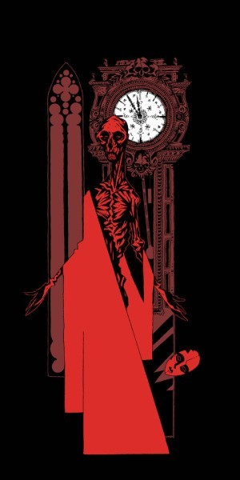

About five or six months into his stay, Prospero decides to have a spectacular **masquerade** ball (a ball where the guests wear masks and costumes). The

setup is **weird and wild**, just like the Prince who designs it. The ball takes place in a suite of seven rooms, each one dressed up in a different color: blue, purple, green, orange, white, violet, and black. The black room, which

looks like death, is awfully **creepy**—it is got dark black walls, blood red windows, and big black clock which chimes so eerily every hour that everybody at the party stops dancing and laughs nervously. Most of the **frolicking** masqueraders are too weirded out to go into the black room.

Anyway, the party's **in full swing** and everybody is having a wild time when the clock strikes midnight. Everyone stops dancing and falls momentarily silent, as usual. Then some of the dancers notice a guest no one had seen before, wearing a scandalous costume. Whoever the new guest is, he's decided to dress as **a corpse**, a corpse who died of… the Red Death. He's so frighteningly lifelike (deathlike?) he **freaks everybody out**, and he slowly starts "stalking" through the frightened crowd. When Prince Prospero sees the ghostly guest, he's furious that someone would have the nerve to wear such a costume and orders him to be **seized** and unmasked. But no one has the guts to do it, including Prospero himself.

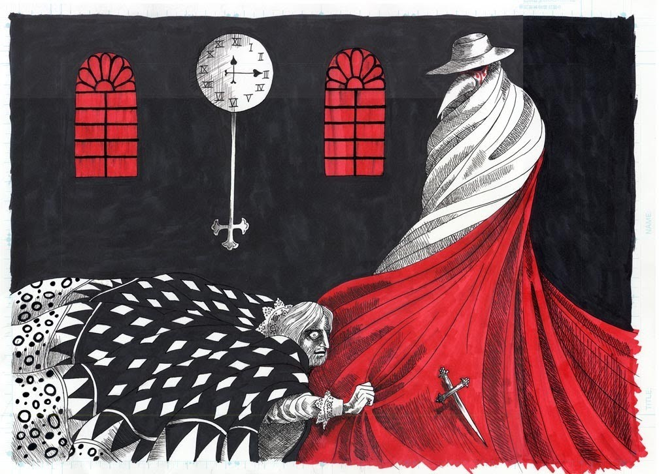

The Red Death masquerader passes within a few feet of the Prince and starts to walk through the rooms, **heading** toward the black room. Prospero loses it and runs after him in a **rage**, drawing his dagger as he approaches. But just as Prospero reaches the edge of the black room, the corpselike guest suddenly whirls around to face him, and Prospero falls to the ground, dead. The shocked crowd throws itself at the guest, only to discover in horror that there is nothing underneath the mask and costume. The Red Death itself has come to the party. One by one the guests die, spilling their blood all over Prospero's **lavish r**ooms. The candles go out, leaving only "darkness, **decay**, and the Red Death."

# 1/ VOCABULARY

**WRITE THE WORDS IN YELOW AND LOOK UP THEIR MEANING IN THE DICTIONARY.**

|  |  |  |
| --- | --- | --- |
| **1** | Gruesome | Causing horror and disgust. |
| **2** | Subjects | Someone or something written about or represented in writing, art or music. |
| **3** | Guest | A person who spends some time at another’ s home in a social activity |
| **4** | Masquerade | A party of people wearing masks. |
| **5** | Weird and wild | Strange and peculiar. |
| **6** | Creepy | Odd and weird. |
| **7** | Frolicking | To play in a frisky, light and manner. |
| **8** | In full swing | To move in a curve. |
| **9** | A corpse | A human or animal body, whether alive or dead. |
| **10** | Freaks everybody out | An act or instance of freaking out. |
| **11** | Seized | To take possession of grasping. |
| **12** | Heading | The compass direction toward which a traveler is moving. |
| **13** | Rage | A fit of violent anger. |
| **14** | Lavish | Spent, given, produced, or occurring in great amounts. |
| **15** | Decay | To decline in health or prosperity |

# 2/ THE STORY

## PROSPERO MAKES A HUGE MISTAKE. WHIICH ONE?

The Red Death masquerader passes within a few feed of the Prince and starts to walk through the rooms, heading toward the black room. Propero makes a mistake, he loses it and runs after him in a range, drawing his dagger as he approaches. But just as Propero reaches the edge of the black room, the corpselike guest duddenly whirls around to face him and Prospero falls to the ground, death.

* **WHY IS A CLOCK SO IMPORTANT IN THIS STORY?**

Because time yet imposes itself as a hug ebony clock, whose pendulum swings with a monotonous and heavy sound. When it strikes the hour, its “ brazen lungs” cause the musicians to arrest their performance and all the guests grow pale, trembling in their apprehension. And, when the final hour bellows from this clock, there appears the horrific figure dressed in the “ habiliments of the grave”.

* **WHICH MORAL CAN BE LEARNED FROM THE STORY?**

The message ( the moral) of Poe’s story, is that no artifice can prevent the inevitability of Fate.