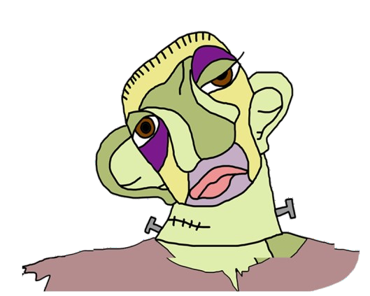MONSTERS

|  |  |  |  |
| --- | --- | --- | --- |
|  | **THE MONSTER**  **OF VICTOR FRANKENSTEIN** | **QUASIMODO** | **THE ELEPHANT MAN** |
| **REAL PERSON OR CHARACTER ?** | Character | Real person | Real person |
| **WHO CREATED HIM?** | He was created by a scientist | His mother | His mother |
| **WHEN ?** | In 1994 | 1831 | 1980 |
| **BOOK HE BELONGS TO** | Frankenstein or modern prometheus | Our lady of Paris | The true story of the elephant man |
| **HIS PROBLEM** | His horrible appearance frightened people and they treated him badly. | He was born deformed and ugly. He was abandoned. People always made fun of him. | The exact cause of Merrick’ s deformities is unclear. In 1986 it was conjectured that he had Proteus syndrome. |
| **COULD HE BE HAPPY?** | Yes | No | He provably becomes happy after a doctor takes care of him |
| **HOW DID HIS LIFE END?** | In the end, he became bad | He goes to Esmeralda’ s grave and refuses to leave her, so he ultimately dies of starvation there. | The official cause of his death was asphyxia. Traves, who performed the autopsy, said Merrick had died of a dislocated neck. |