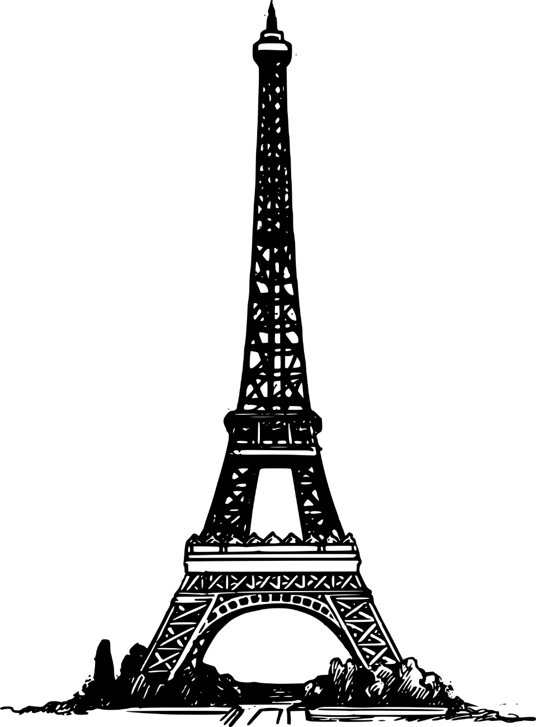

1. **THE OPERA HOUSE:** It’ s important because it was considered one of the master pieces of the Second Empire Style.
2. **THE EIFFEL TOWER:** It’s important because it represents la France.
3. **THE SACRE COEUR:** Being the highest point of the city, this place has always been chosen by the believers, due to the feeling of being closer to the sky, which holds the idea of being closer to god, to heaven and forgiveness in catholicism.
4. **NOTRE DAME:** It’s important because it has long been a symbol of the transcendent human spirit as well as catholic’ s longing for God.
5. **THE PANTHEON:** The Panthéon was a symbol of the monarchy. After the French revolution, the new government transformed it into a place to honour those that had passed away fighting for the new chapter of French history and the greatest French men.
6. **ARC DE TRIOMPHE:** It is an important historical symbol of France national identity.
7. **LES INVALIDES:** It’ s important because it was a residence for retired French soldiers.
8. **MUSÉE DE CLUNY:** There’ sone of the most important medieval artifacts collection.
9. **PLACE RÉPUBLIQUE:** It’s important because there are demonstrations of left
10. **CEMETERY PÈRE LACHAISE:**

It’s de largest park and cemetery of paris.

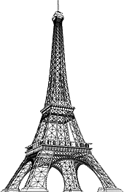

***Paris in the Belle Époque***

**Paris in the Belle Époque was a period in the history of the city between the years 1871 to 1914, from the beginning of the Third French Republic until the First World War.**

**It saw the construction of the Eiffel Tower, the Paris Métro, the completion of the Paris Opera, and the beginning of the Basilica of Sacré-Cœur on Montmartre.**

**Three "universal expositions" in 1878, 1889 and 1900 brought millions of visitors to Paris to sample the latest innovations in commerce, art and technology.**

**Paris was the scene of the first public projection of a motion picture, and the birthplace of the Ballets Russes, Impressionism and Modern Art.**

**The expression Belle Époque ("beautiful era") came into use after the First World War; it was a nostalgic term for what seemed a simpler time of optimism, elegance, and progress.**

SPOT THE FOLLOWING PLACES ON THE MAP AND MARK THEM.

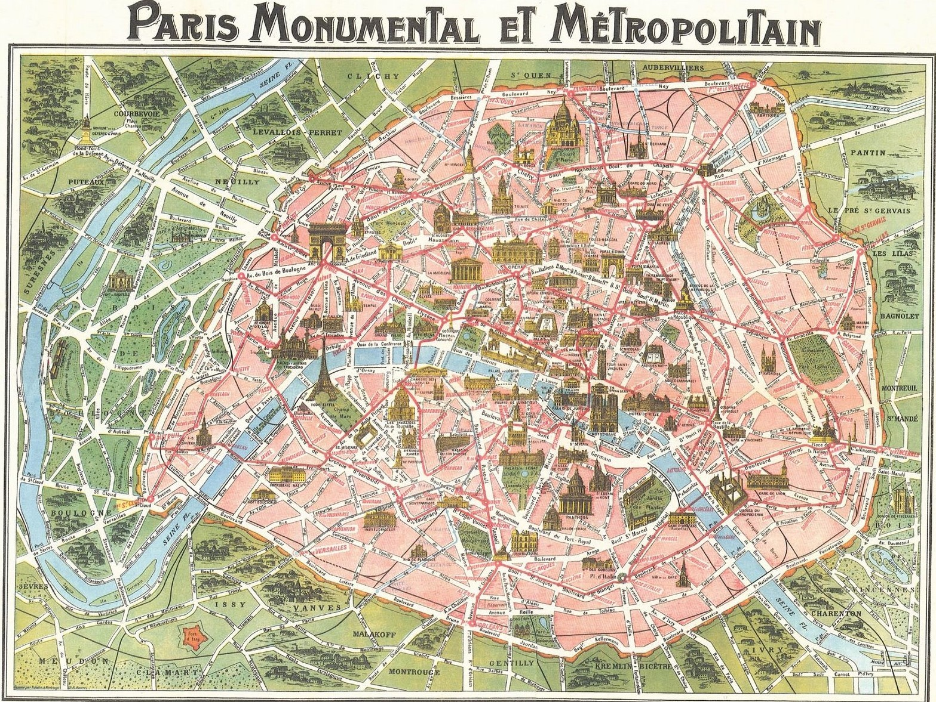

8

9

7

5

10

3

4

1

6

2