FULL NAME Gaston Louis Alfred Leroux

# Gaston Leoux

BIRTH PLACE Paris, France

BIRTH DATE 6 May 1868

Fill in t e FBI’s file fo te suspect Gaston Le oux

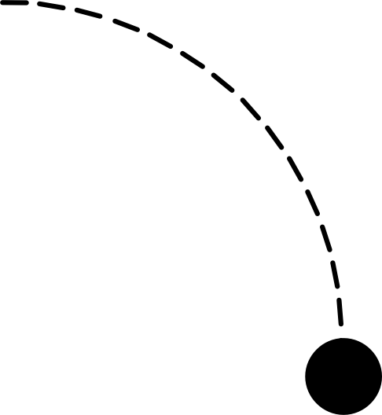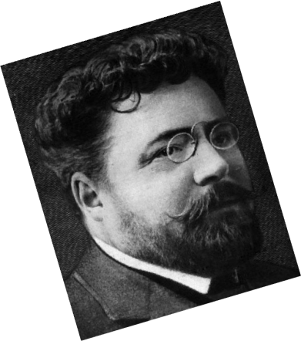

RESIDENCE Pair, Nice and Normandy

PROFESSION: Journalist and author

5 ft 6

PARENTS :

Marie Bidault

Dominique Alfred Leroux

GASTONLEROUX

80 Kg

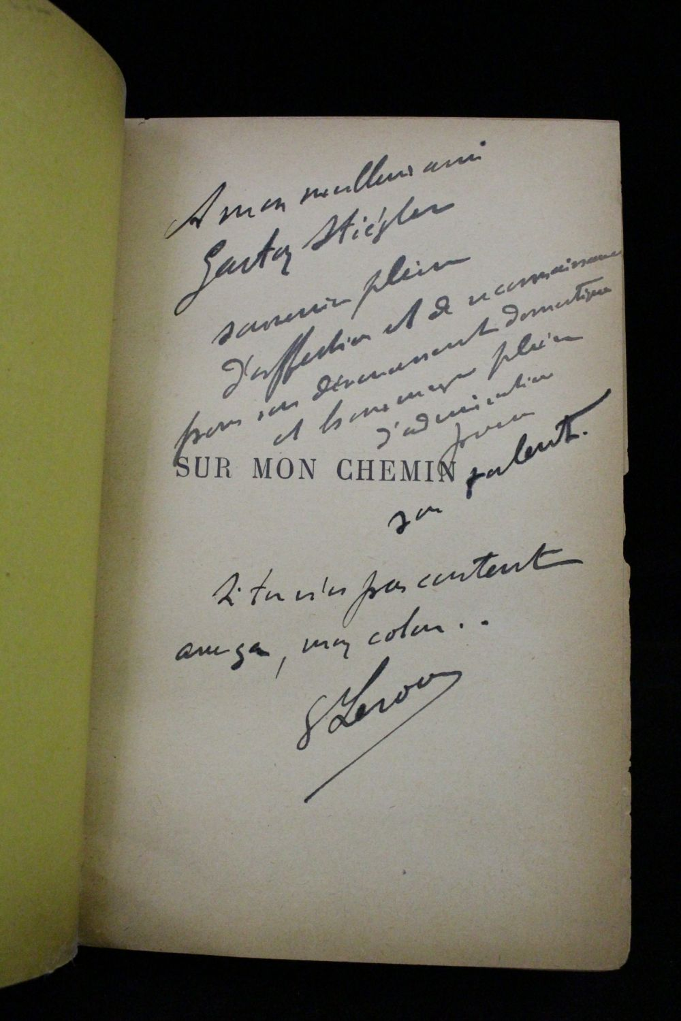

Medeliene Aile

Alfred Gaston

OFFSPRING?

Marie Lefranc

SINGLE/MARRIED ?

BOOKS WRITTEN:

His most famous novels are:

1. The Perfume of the Lady Black (1910)
2. The Phantom of the Opera (1910)
3. The Crime of Rouletabille (1921)
4. The Mystery of the Yellow

15 April 1927

A meme !!

Nice, France

PLACE OF DEATH

DEATH DATE

In Nice, Climetière du Chateau

PLACE OF TOMB